PHP Dynamic Admin Panel

Contents

Introduction 2

Browser Requirements 3

Installation 3

Configuration 4

# Introduction

The PHP Admin panel (PAP) is a free open source project bullied for PHP developer in order to produce time and effort during development cycle

This Version counted as V 0 which mean that you can modify and customize as what fits you and feel free to update us with any suggestion or enhancement.

# Browser Requirements

* PHP 7.0.0

The Admin Panel will work with the following browsers:

* Chrome
* Firefox
* Edge

# Installation

1. 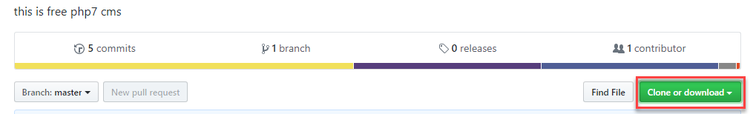**Download the repository PAP app and extract it in your main project directory**
2. **Access PAP directory throw your project URL**

# Configuration

1. **Data base connection settings**

You need to provide

* A host name
* Data Base name
* Data base user name
* 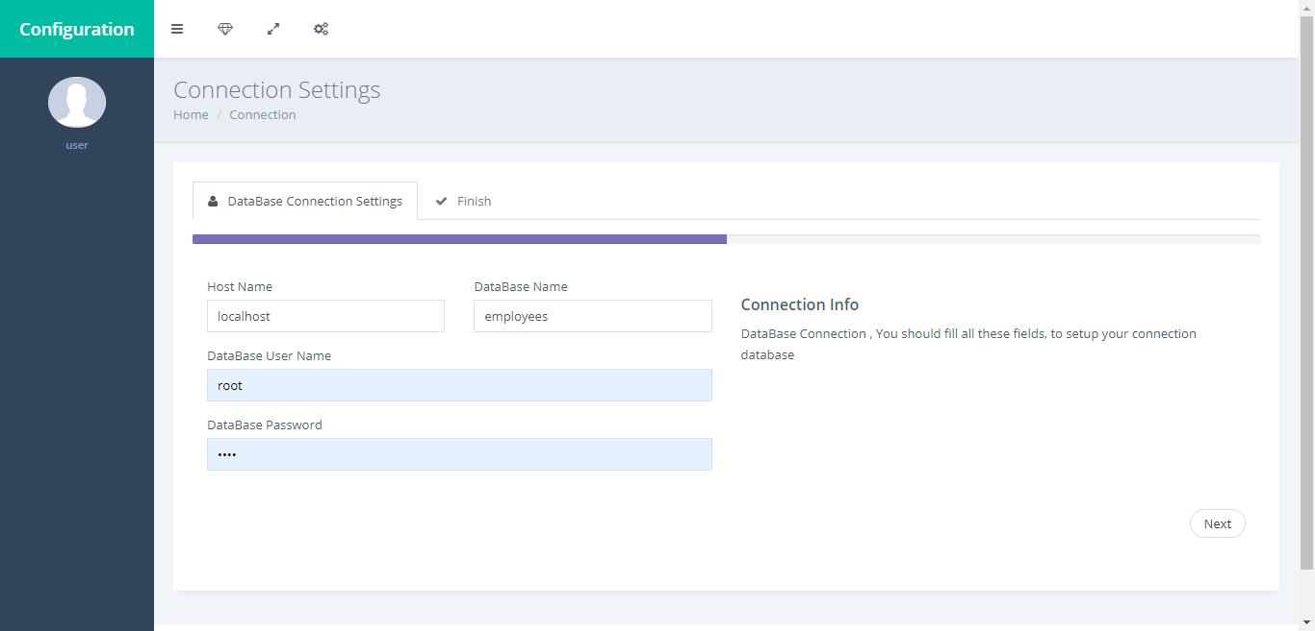Data base Password

1. **Submit**

Make sure to submit all entered data

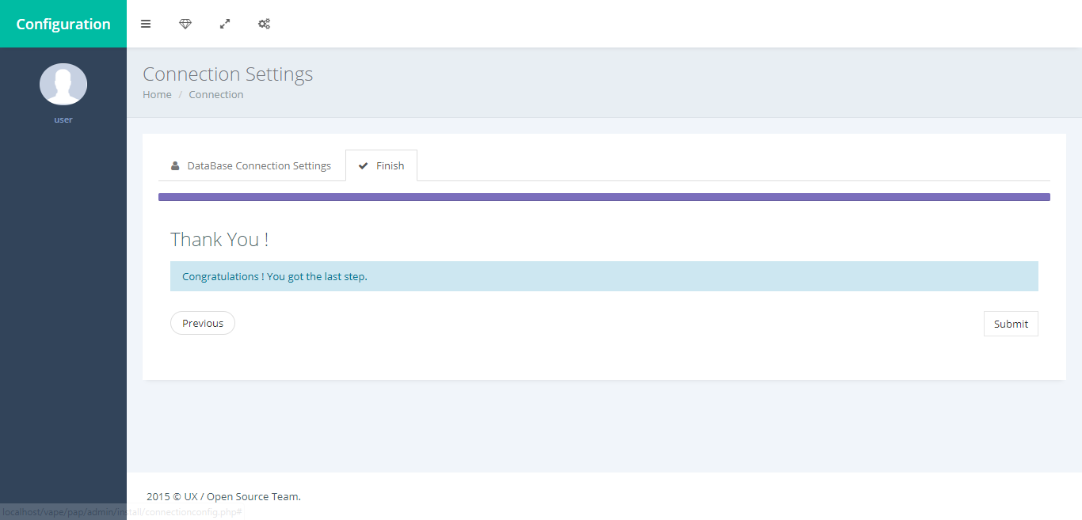

1. **Foreign key**

 You need to define the foreign keys and the display names

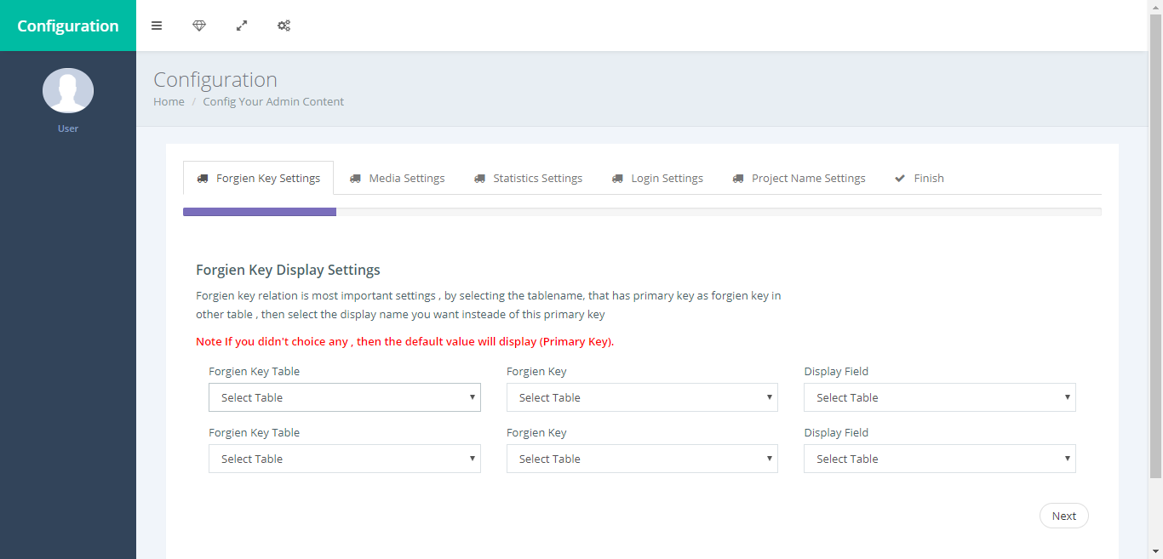

1. **Settings (Image, Video)**Fieldname_Image is the default value to handle the Images uploading (physically exist in default bath\PAP\Admin\authentication\uploads)   
    **Images has default settings**

* Blob datatype (varchar and text are considered as blob, make sure the image field is not type of text) is handled as images upload (image link isn't physical exist).
* Fieldname_Image is default value to handled images upload (physical exist in default path (uploads/) folder)
* If you want to change the default (uploads/) directory please define it down.

**Videos has default settings**

* Fieldname_Youtube or fieldname_youtube are handled as YouTube embedded (physical is not existing on your own media server).
* fieldname_Viedo or fieldname_viedo are handled as media server, that you upload at (default define as fieldname_Viedo or fieldname_Viedo)
* if you want to change the default fieldname_Viedo please define it down.

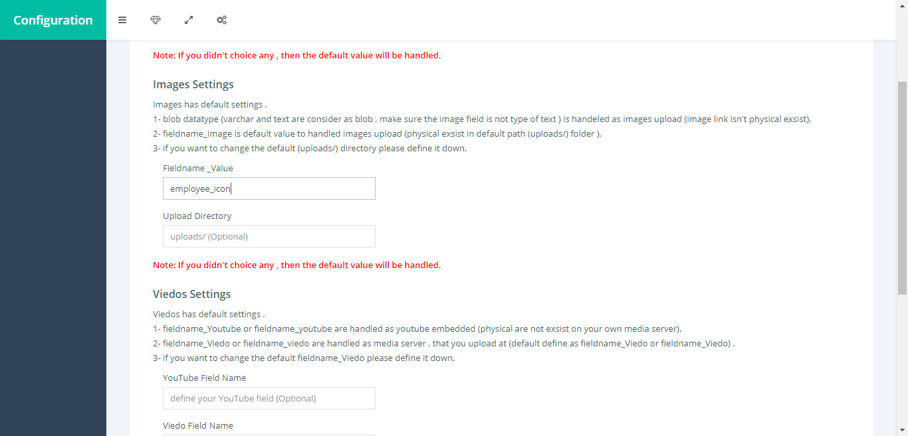

1. 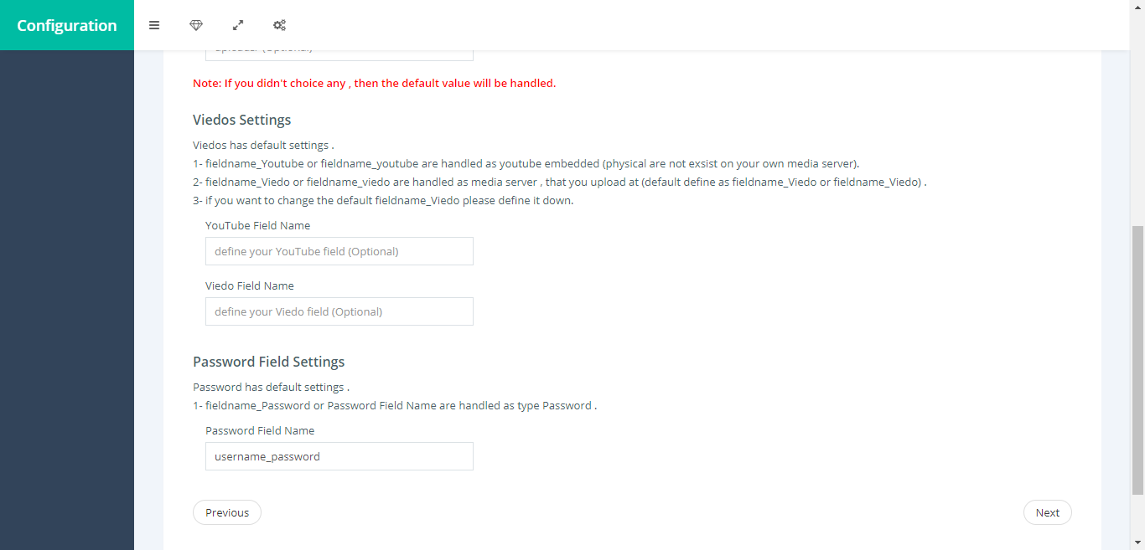**Settings (Password fields)**The default value is Filedname_Password (make sure to contain password word in your table structure) otherwise you can define it in the specific fields
2. 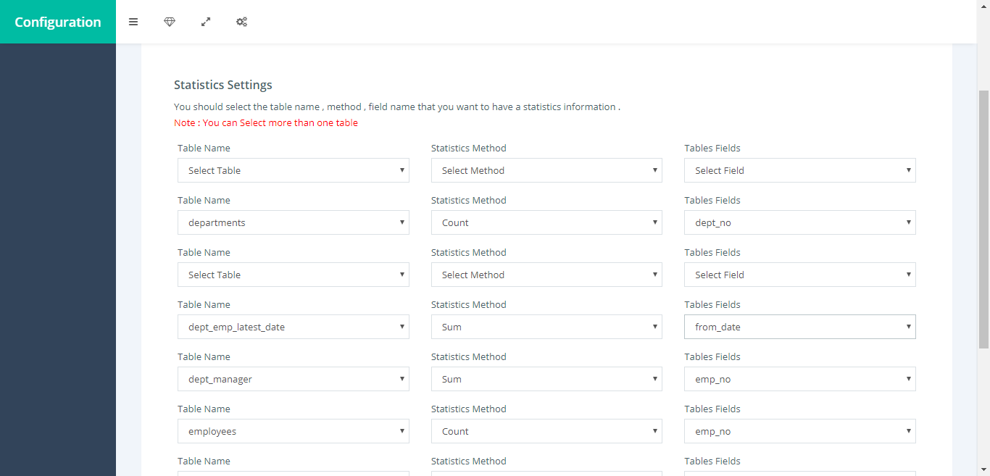**Statistical configuration**If you want to make any statistical chart for any table just make sure to select it
3. 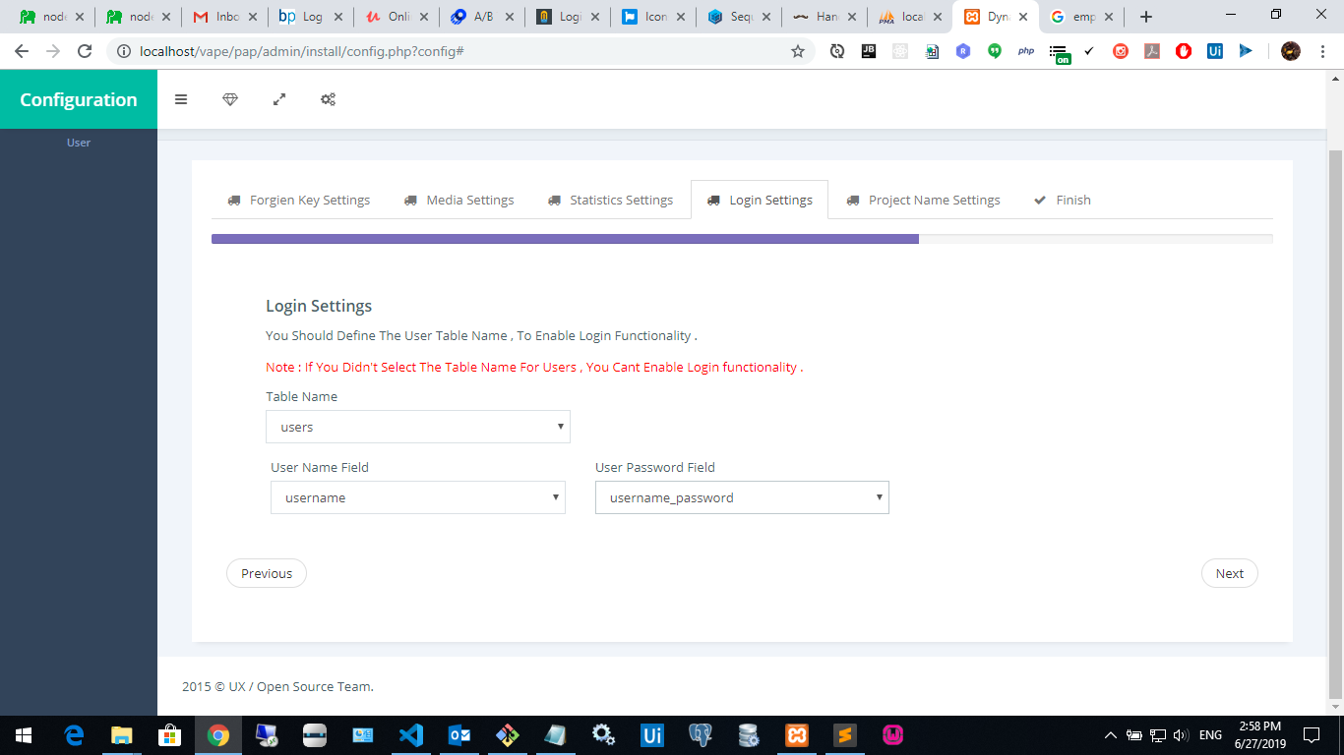**Define user table to access PAP admin panel**make sure the data type of password field is SH1

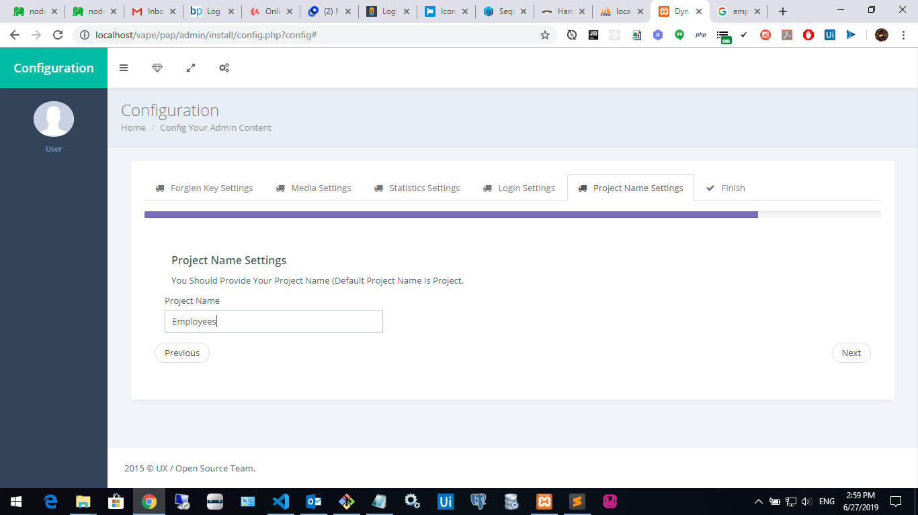**After following all the configuration steps, you will be able to login the PAP**

